CASE STUDY 01 – MANUFACTURING COST AND PROFITABILITY ANALYSIS

1. Problem Statement
A small factory needs to estimate its production expense and check whether its selling price achieves the desired profit margin.

2. Objectives
1. Calculate material, labour, machine and wastage expenses.
2. Find total production cost, sales revenue and profit.
3. Compare actual profit margin with the target.

3. Assumptions
• A batch has 100 units; each unit needs 2 kg of material at Rs. 80/kg.
• Material wastage is 5% of material cost; labour is Rs. 4,000 and machine expense Rs. 2,500.
• Selling price is Rs. 250/unit; target profit margin is 15% of revenue.

4. Algorithm
1. Read batch quantities, rates and target.
2. Calculate material cost and wastage.
3. Add labour and machine charges to find total cost.
4. Calculate revenue, profit and profit margin.
5. Compare margin with target and display decision.

5. Flowchart (using arrows)
START → Set costs and quantity → Calculate material and wastage → Total cost → Revenue and profit → Margin ≥ target? → YES: Target met / NO: Target missed → STOP

6. Pseudocode
START
SET quantity, rates, expenses and target
material = quantity × kg_per_unit × rate
wastage = material × wastage_rate
cost = material + wastage + labour + machine
revenue = quantity × selling_price
profit = revenue - cost
margin = profit / revenue × 100
DISPLAY all amounts and target result
STOP

7. Python Source Code
quantity = 100
kg_per_unit = 2
material_rate = 80
wastage_rate = 0.05
labour = 4000
machine = 2500
selling_price = 250
target_margin = 15

material = quantity * kg_per_unit * material_rate
wastage = material * wastage_rate
total_cost = material + wastage + labour + machine
revenue = quantity * selling_price
profit = revenue - total_cost
margin = profit / revenue * 100 if revenue else 0

print('MANUFACTURING COST REPORT')
print(f'Material: Rs.{material:.2f}')
print(f'Wastage: Rs.{wastage:.2f}')
print(f'Labour: Rs.{labour:.2f}')
print(f'Machine: Rs.{machine:.2f}')
print(f'Total cost: Rs.{total_cost:.2f}')
print(f'Revenue: Rs.{revenue:.2f}')
print(f'Profit: Rs.{profit:.2f}')
print(f'Profit margin: {margin:.2f}%')
print('Target met' if margin >= target_margin else 'Target not met')

8. Test Cases
Input / scenario | Expected result
100 units at Rs.250 | Target not met; margin 6.80%
Selling price Rs.300 | Target met; margin 22.33%
Zero quantity | No revenue; target not met

9. Output Screenshot (executed program)
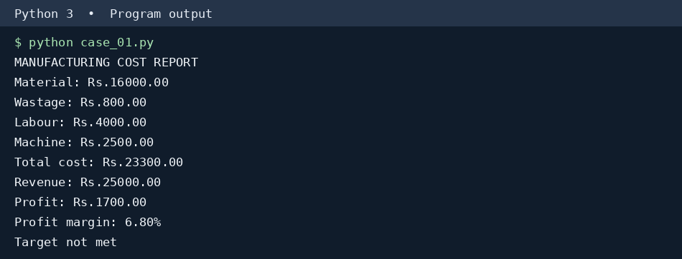

10. Conclusion
The calculation separates direct expenses from revenue and gives a clear decision on the specified profit margin.

CASE STUDY 02 – CAMPUS EVENT FINANCIAL PLANNING

1. Problem Statement
A student committee must estimate event expenses, contributions and sponsorship requirements before opening registrations.

2. Objectives
1. Calculate total event expenditure.
2. Find sponsorship shortfall at a planned registration count.
3. Determine minimum registrations needed to break even.

3. Assumptions
• Venue Rs.12,000; equipment Rs.8,000; catering Rs.150 per participant; transport Rs.5,000; certificates Rs.30 each.
• Registration fee Rs.300, confirmed sponsorship Rs.10,000; planned attendance 150.
• Every registered participant receives catering and a certificate.

4. Algorithm
1. Sum fixed event costs.
2. Find variable cost per participant.
3. Calculate planned expense, fee revenue and shortfall after sponsorship.
4. Divide uncovered fixed costs by contribution per participant and round upward.

5. Flowchart (using arrows)
START → Read costs → Fixed and variable costs → Planned budget → Sponsorship shortfall → Contribution per participant > 0? → YES: Break-even count / NO: Impossible → STOP

6. Pseudocode
START
fixed = venue + equipment + transport
variable = catering + certificate
planned_cost = fixed + variable × planned_count
funds = sponsorship + fee × planned_count
shortfall = MAX(0, planned_cost - funds)
IF fee > variable THEN
break_even = CEILING((fixed - sponsorship)/(fee - variable))
ELSE report impossible
DISPLAY results
STOP

7. Python Source Code
import math
venue, equipment, transport = 12000, 8000, 5000
catering, certificate = 150, 30
fee, sponsor, planned = 300, 10000, 150

fixed = venue + equipment + transport
variable = catering + certificate
expense = fixed + planned * variable
funds = sponsor + planned * fee
shortfall = max(0, expense - funds)
contribution = fee - variable

print('CAMPUS EVENT BUDGET')
print('Fixed cost: Rs.', fixed)
print('Cost per participant: Rs.', variable)
print('Planned expense: Rs.', expense)
print('Available funds: Rs.', funds)
print('Sponsorship shortfall: Rs.', shortfall)
if contribution > 0:
minimum = max(0, math.ceil((fixed - sponsor) / contribution))
print('Break-even registrations:', minimum)
else:
print('Break-even is not possible with this fee')

8. Test Cases
Input / scenario | Expected result
150 registrations | Shortfall Rs.0; minimum 125
100 registrations | Shortfall Rs.3,000
Fee Rs.180 | Break-even not possible

9. Output Screenshot (executed program)
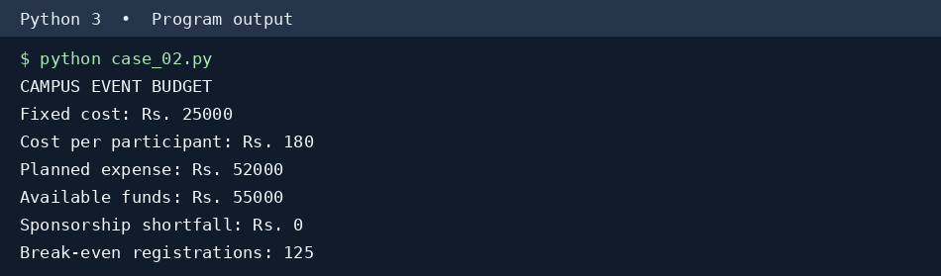

10. Conclusion
The committee can adjust fees, sponsorship or attendance expectations before committing to event expenses.

CASE STUDY 03 – ATTENDANCE RECOVERY COMPUTATION

1. Problem Statement
A student wants to know how many more classes must be attended to become eligible for an examination.

2. Objectives
1. Calculate present attendance percentage.
2. Determine the minimum consecutive attended classes to reach 75%.
3. Compare full-attendance and partial-attendance future plans.

3. Assumptions
• There have been 80 classes and the student attended 52.
• Eligibility threshold is 75%.
• For the second scenario, the student attends 4 of every 5 future classes; missing classes are counted.

4. Algorithm
1. Calculate the current percentage.
2. For each scenario, add future classes in the stated pattern.
3. Stop when the attendance threshold is achieved.
4. Report the number of additional classes and classes attended.

5. Flowchart (using arrows)
START → Current percentage → Select future pattern → Add next class → Update attended and total → Percentage ≥ 75%? → NO: Repeat / YES: Show classes needed → STOP

6. Pseudocode
START
FOR each future pattern
attended = current_attended; total = current_total
WHILE attendance < threshold
total = total + 1
IF pattern says present THEN attended = attended + 1
DISPLAY total extra classes and future attended
STOP

7. Python Source Code
attended_now, total_now = 52, 80
threshold = 75

print('ATTENDANCE RECOVERY')
print(f'Current attendance: {attended_now / total_now * 100:.2f}%')
for label, cycle in [('Every class', [1]), ('4 of every 5', [1, 1, 1, 1, 0])]:
attended, total, extra, future_present = attended_now, total_now, 0, 0
while attended * 100 < threshold * total:
present = cycle[extra % len(cycle)]
attended += present
future_present += present
total += 1
extra += 1
print(f'{label}: {extra} extra classes, {future_present} attended')
print(f' Final attendance: {attended / total * 100:.2f}%')

8. Test Cases
Input / scenario | Expected result
52 of 80; all future attended | 32 more classes
52 of 80; 4 out of 5 | 160 more classes
Already 75% or higher | 0 more classes

9. Output Screenshot (executed program)
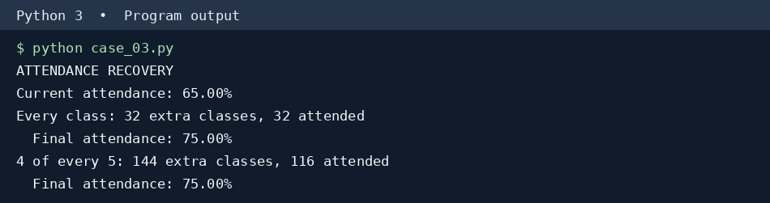

10. Conclusion
Attending every future class improves attendance faster; even occasional absences can greatly extend recovery time.

CASE STUDY 04 – STUDENT PERFORMANCE TREND ANALYSIS

1. Problem Statement
A class teacher needs to compare three examinations, detect weak subjects and classify each student.

2. Objectives
1. Calculate subject-wise changes and overall averages.
2. Identify consistently weak subjects across examinations.
3. Classify student progress using a defined rule.

3. Assumptions
• Three examinations are recorded for Mathematics, Python and Physics.
• A subject is consistently weak if its mark is below 50 in all three exams.
• Improving: final average at least 5 marks above first; Declining: at least 5 below; otherwise Stable.

4. Algorithm
1. Store each student’s three exam scores.
2. Calculate the average for each exam.
3. Subtract first-exam average from final-exam average.
4. Find subjects below 50 in all exams.
5. Assign and print a trend label.

5. Flowchart (using arrows)
START → Read student scores → Exam averages → Final minus first → Check all-exam weak subjects → Change ≥ 5? / ≤ -5? → Classify → Display → STOP

6. Pseudocode
START
FOR each student
COMPUTE average marks in each exam
change = final_average - first_average
FOR each subject check all three marks < 50
IF change >= 5 classify Improving
ELSE IF change <= -5 classify Declining
ELSE classify Stable
DISPLAY results
STOP

7. Python Source Code
subjects = ['Maths', 'Python', 'Physics']
students = {
'Anu': [[55, 65, 48], [65, 72, 49], [75, 80, 47]],
'Bala': [[78, 70, 66], [70, 68, 60], [62, 60, 54]],
'Chitra': [[65, 72, 60], [68, 70, 63], [67, 73, 61]]
}

print('STUDENT PERFORMANCE TRENDS')
for name, exams in students.items():
averages = [sum(exam) / len(exam) for exam in exams]
change = averages[-1] - averages[0]
weak = [subjects[i] for i in range(len(subjects))
if all(exam[i] < 50 for exam in exams)]
if change >= 5:
status = 'Improving'
elif change <= -5:
status = 'Declining'
else:
status = 'Stable'
print(f'{name}: {[round(x, 1) for x in averages]}')
print(f' Change: {change:+.2f}, Trend: {status}')
print(' Consistently weak:', ', '.join(weak) or 'None')

8. Test Cases
Input / scenario | Expected result
Anu | Improving; Physics consistently weak
Bala | Declining
Chitra | Stable

9. Output Screenshot (executed program)
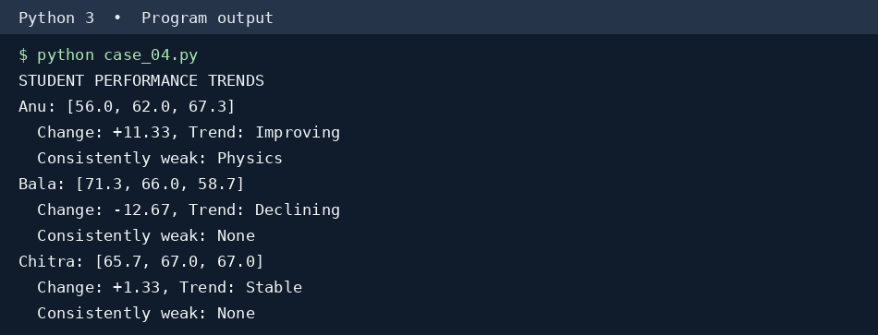

10. Conclusion
This report highlights changing performance and subjects needing focused practice.

CASE STUDY 05 – TRAFFIC VIOLATION PENALTY CALCULATOR

1. Problem Statement
A traffic office wants a simple calculator that combines vehicle type, offence, and repeat-offence status.

2. Objectives
1. Apply a predefined fine table.
2. Calculate total fines for multiple violations.
3. Identify disqualification under the case-study rules.

3. Assumptions
• These are illustrative classroom fines, not official legal rates.
• Base fines: helmet Rs.1,000; signal Rs.2,000; speeding Rs.1,500; drunk driving Rs.10,000.
• Car multiplier 1.5; bike multiplier 1.0. Repeat offences double the applicable fine.
• Any drunk-driving violation or three or more violations triggers a disqualification flag.

4. Algorithm
1. Read vehicle category and violation records.
2. Look up the base fine and category multiplier.
3. Double the amount for repeated offences.
4. Add all fines and test disqualification conditions.

5. Flowchart (using arrows)
START → Vehicle type → For each violation → Base fine → Vehicle multiplier → Repeat? → Add fine → More violations? → Disqualification check → Print → STOP

6. Pseudocode
START
SET base fines and vehicle multipliers
FOR each violation
fine = base[offence] × multiplier[vehicle]
IF repeat THEN fine = fine × 2
ADD fine to total
IF drunk driving present OR count >= 3 THEN disqualified
DISPLAY total and status
STOP

7. Python Source Code
fines = {'helmet': 1000, 'signal': 2000,
'speeding': 1500, 'drunk driving': 10000}
multipliers = {'bike': 1.0, 'car': 1.5}
vehicle = 'car'
violations = [('signal', False), ('speeding', True)]

total = 0
print('TRAFFIC VIOLATION REPORT')
print('Vehicle:', vehicle)
for offence, repeat in violations:
if offence not in fines:
print('Unknown offence:', offence)
continue
amount = fines[offence] * multipliers[vehicle]
if repeat:
amount *= 2
total += amount
print(f'{offence} (repeat={repeat}): Rs.{amount:.2f}')
disqualified = any(offence == 'drunk driving' for offence, _ in violations)
disqualified = disqualified or len(violations) >= 3
print(f'Total penalty: Rs.{total:.2f}')
print('Disqualification:', 'YES' if disqualified else 'NO')

8. Test Cases
Input / scenario | Expected result
Car: signal + repeat speeding | Rs.7,500; not disqualified
Any drunk driving | Disqualified
Three violations | Disqualified

9. Output Screenshot (executed program)
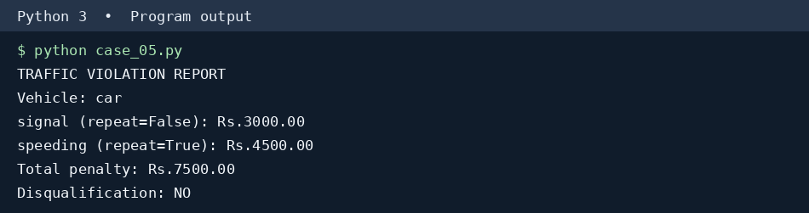

10. Conclusion
The program illustrates rule-based fine calculation; actual traffic laws and rates must be checked separately.

CASE STUDY 06 – PROGRESSIVE WATER TARIFF ANALYSIS

1. Problem Statement
A water utility needs to bill households according to consumption slabs and detect unusually high usage.

2. Objectives
1. Calculate progressive water charges for each household.
2. Add fixed charges and excess-use penalties.
3. Compare total household consumption.

3. Assumptions
• First 10 kL cost Rs.5/kL, next 10 kL Rs.10/kL, remaining kL Rs.20/kL.
• Fixed charge Rs.50; consumption above 30 kL adds a Rs.100 penalty.
• More than 30 kL is flagged as excessive.

4. Algorithm
1. Read household usage.
2. Charge the first 10, next 10 and remaining units separately.
3. Add the fixed fee and any penalty.
4. Display household bills and highest consumption.

5. Flowchart (using arrows)
START → Read household units → Calculate slab 1 → Slab 2 → Slab 3 → Add fixed charge → Units > 30? → Add penalty/flag → Print bills → STOP

6. Pseudocode
START
FOR each household
first = MIN(units,10) × 5
second = MIN(MAX(units-10,0),10) × 10
third = MAX(units-20,0) × 20
penalty = 100 IF units > 30 ELSE 0
bill = first + second + third + 50 + penalty
DISPLAY bill and excess-use flag
STOP

7. Python Source Code
households = {'House A': 8, 'House B': 18,
'House C': 28, 'House D': 35}

print('WATER BILL REPORT')
for name, units in households.items():
if units < 0:
print(name, 'Invalid consumption')
continue
first = min(units, 10) * 5
second = min(max(units - 10, 0), 10) * 10
third = max(units - 20, 0) * 20
penalty = 100 if units > 30 else 0
bill = first + second + third + 50 + penalty
print(f'{name}: {units} kL, Bill Rs.{bill:.2f}',
'EXCESSIVE' if units > 30 else 'Normal')
print('Highest user:', max(households, key=households.get))

8. Test Cases
Input / scenario | Expected result
8 kL | Bill Rs.90
18 kL | Bill Rs.180
35 kL | Bill Rs.600; excessive

9. Output Screenshot (executed program)
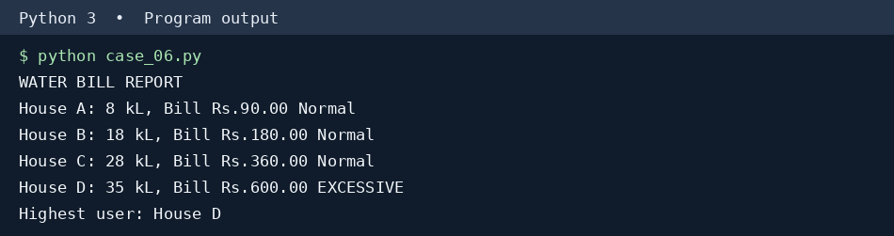

10. Conclusion
Progressive slabs charge heavy users more and help identify households with unusually high consumption.

CASE STUDY 07 – ATM MENU-DRIVEN BANKING SIMULATION

1. Problem Statement
Create a simple ATM that repeatedly accepts deposits, withdrawals and balance enquiries until the user exits.

2. Objectives
1. Provide deposit, withdrawal, balance and summary options.
2. Validate positive amounts, balance and transaction limits.
3. Keep a transaction history.

3. Assumptions
• Opening balance Rs.5,000.
• Single deposit maximum Rs.20,000 and withdrawal maximum Rs.10,000.
• Minimum balance after withdrawal Rs.500.
• The demonstration runs a predetermined menu sequence; the same function can be used with keyboard input.

4. Algorithm
1. Show menu repeatedly.
2. Read an option and amount when needed.
3. Validate and update balance for allowed transactions.
4. Record successful transactions and show summary.
5. Stop on exit.

5. Flowchart (using arrows)
START → Show menu → Choice? → Deposit / Withdraw / Balance / Summary / Exit → Validate → Update or reject → Return to menu → STOP

6. Pseudocode
START
balance = 5000
REPEAT
READ choice
IF deposit: validate amount and add
ELSE IF withdraw: validate limit and minimum balance
ELSE IF balance: display balance
ELSE IF summary: display history
UNTIL choice is Exit
STOP

7. Python Source Code
balance = 5000
history = []
# Replace this demonstration list with input() for live use.
operations = [('deposit', 2000), ('withdraw', 1500),
('withdraw', 7000), ('balance', 0),
('summary', 0), ('exit', 0)]

print('ATM BANKING SIMULATION')
for choice, amount in operations:
print('Option:', choice, 'Amount:', amount)
if choice == 'deposit':
if 0 < amount <= 20000:
balance += amount
history.append(('Deposit', amount))
print('Deposit successful')
else:
print('Invalid deposit')
elif choice == 'withdraw':
if 0 < amount <= 10000 and balance - amount >= 500:
balance -= amount
history.append(('Withdrawal', amount))
print('Withdrawal successful')
else:
print('Withdrawal rejected')
elif choice == 'balance':
print('Balance: Rs.', balance)
elif choice == 'summary':
print('Transactions:', history)
elif choice == 'exit':
print('Session ended')
break
else:
print('Invalid option')
print('Final balance: Rs.', balance)

8. Test Cases
Input / scenario | Expected result
Deposit Rs.2,000 | Accepted
Withdraw Rs.1,500 | Accepted
Withdraw Rs.7,000 after above | Rejected; minimum balance
Balance inquiry | Rs.5,500

9. Output Screenshot (executed program)
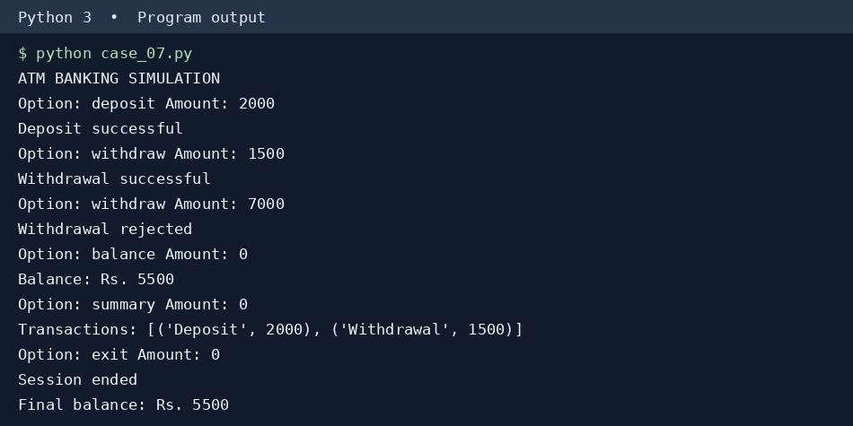

10. Conclusion
A menu-driven loop can safely process repeated banking requests when each transaction is validated.

CASE STUDY 08 – WEEKLY ELECTRICITY CONSUMPTION MATRIX

1. Problem Statement
A hostel room records daily energy usage of appliances for one week and wants a weekly summary.

2. Objectives
1. Store readings in a 2D matrix.
2. Calculate appliance totals and daily totals.
3. Flag days and appliances that exceed usage limits.

3. Assumptions
• Readings are in kWh for Monday through Sunday.
• Daily usage limit is 12 kWh; appliance weekly limit is 20 kWh.
• Rows represent appliances and columns represent days.

4. Algorithm
1. Store the readings as a matrix.
2. Sum each row to obtain appliance totals.
3. Sum each column to obtain daily totals.
4. Compare totals with limits and display warnings.

5. Flowchart (using arrows)
START → Read matrix → Sum rows → Sum columns → Compare daily limit → Compare appliance limit → Display warnings → STOP

6. Pseudocode
START
STORE appliance × day matrix
FOR each appliance calculate row sum
FOR day = 1 TO 7 calculate column sum
IF day total > daily limit flag day
IF appliance total > weekly limit flag appliance
DISPLAY totals
STOP

7. Python Source Code
days = ['Mon', 'Tue', 'Wed', 'Thu', 'Fri', 'Sat', 'Sun']
appliances = ['Fan', 'AC', 'Lights']
readings = [
[2, 2, 2, 2, 2, 3, 3],
[6, 7, 8, 6, 7, 9, 8],
[2, 2, 2, 3, 2, 3, 2]
]
daily_limit, weekly_limit = 12, 20

print('WEEKLY ELECTRICITY REPORT')
for name, row in zip(appliances, readings):
total = sum(row)
print(f'{name}: {total} kWh',
'OVER LIMIT' if total > weekly_limit else '')
for day_index, day in enumerate(days):
total = sum(row[day_index] for row in readings)
print(f'{day}: {total} kWh',
'OVER LIMIT' if total > daily_limit else '')
print('Weekly total:', sum(map(sum, readings)), 'kWh')

8. Test Cases
Input / scenario | Expected result
Monday | 10 kWh; within limit
Saturday | 15 kWh; over daily limit
AC weekly total | 51 kWh; over weekly limit

9. Output Screenshot (executed program)
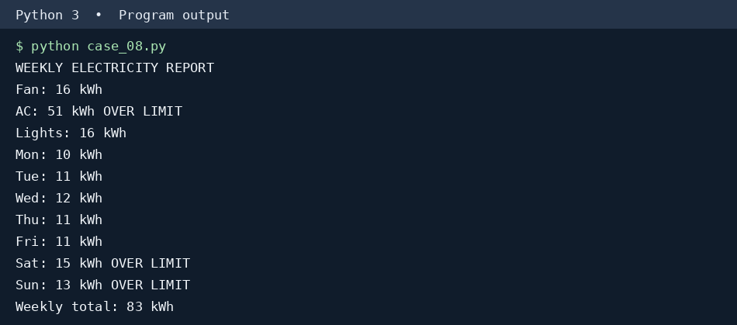

10. Conclusion
A two-dimensional list makes it easy to compare daily consumption and appliance-level electricity demand.

CASE STUDY 09 – BUS PASSENGER OCCUPANCY SIMULATION

1. Problem Statement
A bus conductor records passengers boarding and leaving at each stop and checks capacity compliance.

2. Objectives
1. Update passenger counts after every stop.
2. Reject invalid alighting counts.
3. Identify stops where the bus exceeds capacity.

3. Assumptions
• Bus capacity is 40 and starts empty.
• At each stop passengers alight before new passengers board.
• A capacity violation is flagged, but the recorded occupancy is retained for analysis.

4. Algorithm
1. Read stop-wise boarding and alighting counts.
2. Check whether alighting exceeds onboard passengers.
3. Update occupancy after alighting and boarding.
4. Compare occupancy against bus capacity.

5. Flowchart (using arrows)
START → Initial passengers 0 → Next stop → Validate alighting → Subtract alighting → Add boarding → Occupancy > capacity? → Flag if YES → Next stop / STOP

6. Pseudocode
START
passengers = 0
FOR each stop
IF alighting > passengers THEN reject stop
ELSE passengers = passengers - alighting + boarding
DISPLAY passengers
IF passengers > capacity THEN flag violation
STOP

7. Python Source Code
capacity = 40
stops = [('Stop 1', 20, 0), ('Stop 2', 25, 5),
('Stop 3', 8, 12), ('Stop 4', 2, 20)]
passengers = 0

print('BUS OCCUPANCY REPORT')
for name, boarding, alighting in stops:
if boarding < 0 or alighting < 0 or alighting > passengers:
print(name, ': Invalid passenger count')
continue
passengers = passengers - alighting + boarding
print(f'{name}: Onboard {passengers}',
'CAPACITY VIOLATION' if passengers > capacity else 'OK')
print('Final occupancy:', passengers)

8. Test Cases
Input / scenario | Expected result
Stop 1: +20, -0 | 20 passengers
Stop 2: +25, -5 | 40 passengers
Stop 3: +8, -12 | 36 passengers
Alighting exceeds occupancy | Invalid stop

9. Output Screenshot (executed program)
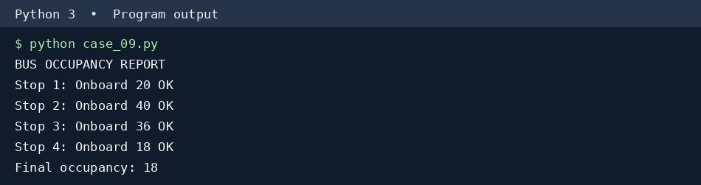

10. Conclusion
The simulation gives stop-by-stop occupancy and highlights unsafe passenger loads.

CASE STUDY 10 – SMART CANTEEN ORDER AND STOCK MANAGEMENT

1. Problem Statement
A college canteen receives several customer orders and must keep inventory accurate while recording sales.

2. Objectives
1. Check ordered quantities against stock.
2. Calculate each customer bill and update inventory.
3. Report total sales and remaining stock.

3. Assumptions
• Sandwich costs Rs.60 with 8 in stock; tea Rs.15 with 15; juice Rs.40 with 6.
• An order is accepted only if all requested quantities are available.
• Rejected orders do not change inventory or sales.

4. Algorithm
1. Store item prices and stock.
2. Read successive customer orders.
3. Check every requested quantity and item name.
4. Reject the whole order if any item is unavailable.
5. Otherwise calculate the bill, deduct stock and add sales.

5. Flowchart (using arrows)
START → Load menu and stock → Read order → All items and quantities valid? → NO: Reject → YES: Bill and deduct stock → More orders? → Summary → STOP

6. Pseudocode
START
STORE price and stock for each item
FOR each order
valid = TRUE
FOR each requested item check quantity and stock
IF invalid THEN reject order
ELSE calculate bill, update stock and sales
DISPLAY total sales and stock remaining
STOP

7. Python Source Code
menu = {'sandwich': [60, 8], 'tea': [15, 15],
'juice': [40, 6]}
orders = [
('Customer 1', {'sandwich': 2, 'tea': 2}),
('Customer 2', {'juice': 7}),
('Customer 3', {'juice': 3, 'sandwich': 1})
]
sales = 0

print('SMART CANTEEN REPORT')
for customer, items in orders:
valid = all(item in menu and isinstance(qty, int)
and qty > 0 and qty <= menu[item][1]
for item, qty in items.items()) and bool(items)
if not valid:
print(customer, ': Order rejected (invalid or low stock)')
continue
bill = sum(menu[item][0] * qty for item, qty in items.items())
for item, qty in items.items():
menu[item][1] -= qty
sales += bill
print(f'{customer}: Bill Rs.{bill}')
print('Daily sales: Rs.', sales)
for item, (price, stock) in menu.items():
print(f'{item}: {stock} remaining')

8. Test Cases
Input / scenario | Expected result
Customer 1: 2 sandwiches, 2 teas | Bill Rs.150
Customer 2: 7 juices | Rejected
Customer 3: 3 juices, 1 sandwich | Bill Rs.180

9. Output Screenshot (executed program)
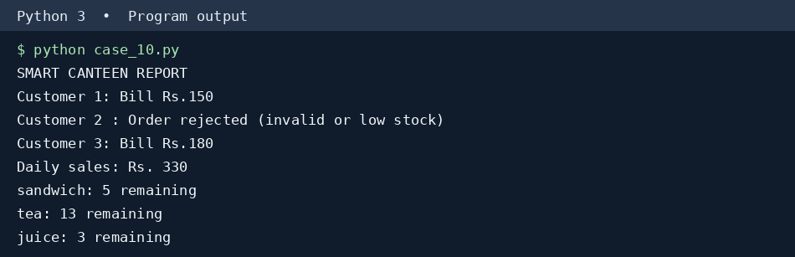

10. Conclusion
The canteen avoids overselling stock and maintains an accurate daily sales total.

